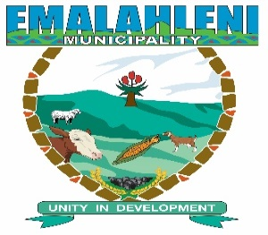
Media Statement
23 May 2018
To: The Manager/Editor/Reporter
All Media
Subject: Handover of Daisy Player for Blind Library Members
Emalahleni Local Municipality together with South African Library for the Blind (SALB) will hand over the Daisy Player machines to blind Library members TO BE BASED AT Mlungisi Wycliff Tsotsi Library on the 24 May 2018 at Cacadu Town Hall at 11:00 am.
South African Library for the Blind (SALB) has an initiative to assist blind library member’s access audio book. This audio book reader is in form of a daisy player machine that makes it possible for blind person to read a book from compact Disc (CD)
Members of the media are invited to attend this programme.
For more information contact Emalahleni Local Municipality Communications Section @0478780020/0797020166.
Issued by the office of the Municipal Manager, Communications Section Emalahleni Local Municipality.

